Log Monitoring & Analysis Report

1. Introduction
This report details a log monitoring and analysis exercise, focusing on authentication logs to identify potential security incidents such as brute-force attacks and anomalous login patterns. The analysis was performed using synthetic log data generated to simulate real-world scenarios.

2. Log Types and Collection
For this exercise, SSH authentication logs were simulated. In a real-world scenario, various log types are crucial for comprehensive security monitoring, including:

- Authentication Logs: Record user login attempts, both successful and failed. (e.g., /var/log/auth.log on Linux)
- System Logs: General system activities, kernel messages, and service status. (e.g., /var/log/syslog, /var/log/messages)
- Application Logs: Specific events generated by applications, providing insights into their behavior.
- Web Server Logs: Record HTTP requests, client IP addresses, requested resources, and response codes. (e.g., Apache, Nginx access logs)
- Firewall Logs: Detail network traffic allowed or denied by firewall rules.

For this report, synthetic SSH authentication logs were generated using a Python script (generate_logs_v2.py) to create a dataset for analysis. The logs include timestamps, source IP addresses, usernames, and authentication outcomes (successful or failed).

3. Authentication Log Analysis

Failed Login Attempts
Analysis of failed login attempts is critical for detecting malicious activities such as brute-force attacks or password guessing. The generated logs show a significant number of failed login attempts.

Top Targeted Users
The following chart illustrates the top 10 usernames that were most frequently targeted by failed login attempts. The root user is often a primary target due to its elevated privileges.

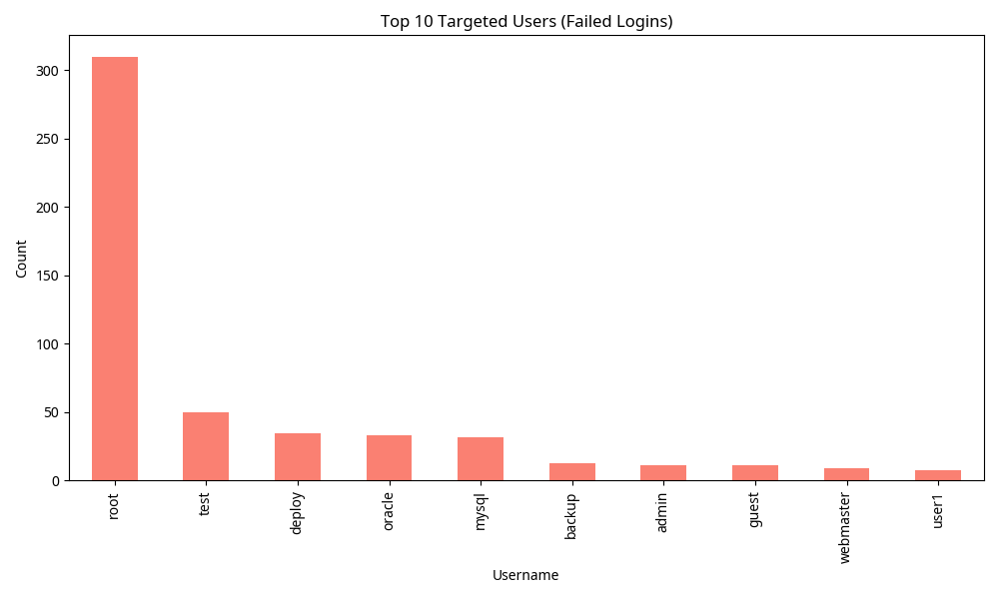

Top Attacking IP Addresses
Identifying the source IP addresses of failed login attempts helps in pinpointing potential attackers. The chart below highlights the IP addresses with the highest number of failed login attempts.

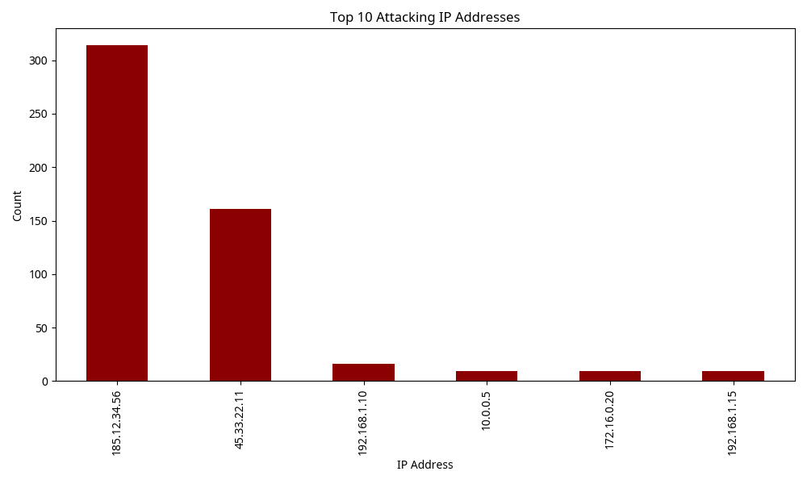

Login Attempt Success vs. Failure Ratio
The overall ratio of successful to failed login attempts provides a high-level overview of authentication security. A high percentage of failed attempts can indicate ongoing attacks or misconfigurations.

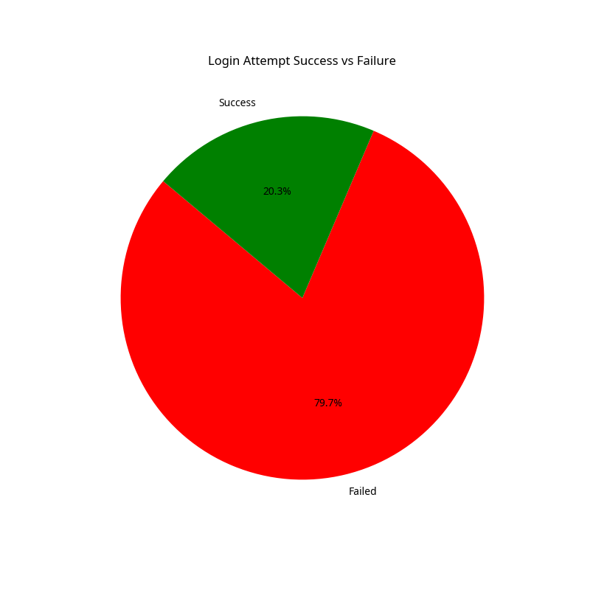

4. Anomaly Detection and Event Correlation
Anomaly detection involves identifying patterns that deviate significantly from normal behavior. Event correlation links multiple log entries to form a broader picture of an incident.

Brute Force Detection
Our analysis script (analyze_logs.py) was configured to detect brute-force attacks by identifying IP addresses with more than 10 failed login attempts within a 5-minute window. The following alerts were generated:

Brute Force Alerts (More than 10 failures in 5 mins):
ip timestamp count
20 185.12.34.56 2026-02-14 13:15:00 23
21 185.12.34.56 2026-02-14 13:20:00 151
22 185.12.34.56 2026-02-14 13:25:00 130
51 45.33.22.11 2026-02-14 13:45:00 16
52 45.33.22.11 2026-02-14 13:50:00 100
53 45.33.22.11 2026-02-14 13:55:00 35

This indicates two distinct brute-force attacks originating from 185.12.34.56 and 45.33.22.11 at different time intervals.

Failed Login Attempts Over Time
The timeline of failed login attempts visually represents the intensity and duration of potential attacks. Peaks in this graph correspond to periods of increased malicious activity.

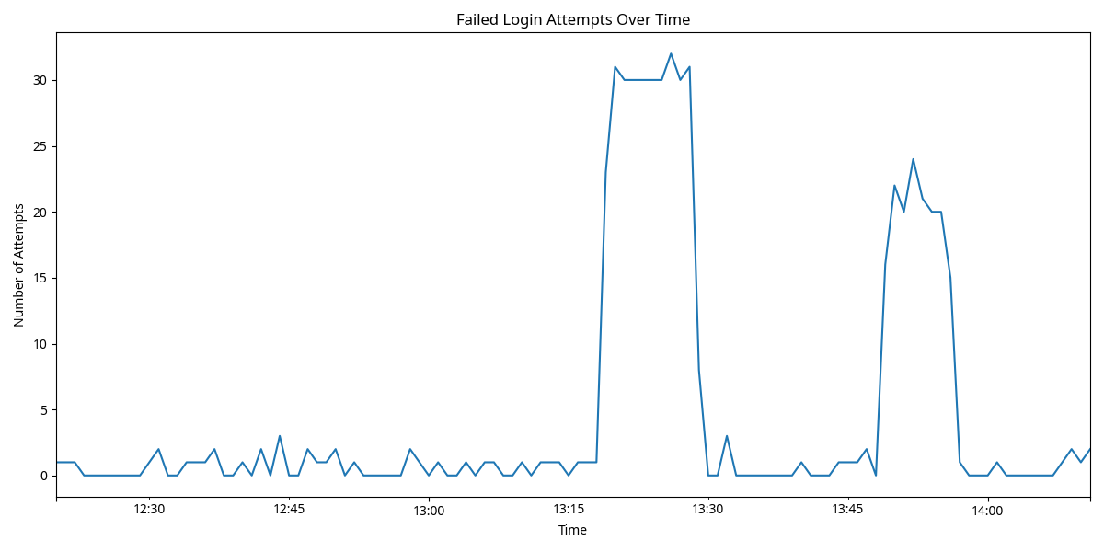

5. SIEM Basics and Alert Writing

Security Information and Event Management (SIEM)
SIEM systems aggregate and analyze log data from various sources across an organization's IT infrastructure. They provide centralized visibility, enabling real-time monitoring, threat detection, and compliance reporting. Key functions of SIEM include:

- Data Aggregation: Collecting logs from diverse systems.
- Data Normalization: Parsing and standardizing log formats.
- Correlation: Identifying relationships between seemingly unrelated events.
- Alerting: Notifying security personnel of detected threats.
- Reporting: Generating reports for compliance and incident analysis.

Writing Effective Alerts
Effective alerts are crucial for timely incident response. An alert should be:

- Actionable: Provide enough information for a security analyst to investigate.
- Specific: Clearly define the condition that triggered it.
- Prioritized: Indicate the severity of the threat.
- Contextual: Include relevant details like source IP, username, and time.

Example Alert (Brute Force Detection):

Alert Name: Brute Force Attack Detected
Severity: High
Trigger Condition: More than 10 failed login attempts from a single IP address to any user within a 5-minute window.
Details:
- Attacking IP: {IP_Address}
- Targeted User(s): {Usernames}
- Number of Failed Attempts: {Count}
- Time Window: {Start_Time} - {End_Time}
Recommended Action: Block attacking IP, investigate targeted accounts, review user access policies.

6. Conclusion
This exercise demonstrated the fundamental steps in log monitoring and analysis, from understanding log types and collecting data to detecting anomalies and correlating events. The generated report highlights the importance of analyzing failed login attempts, identifying top attacking IPs and targeted users, and visualizing trends over time. These practices are foundational for effective incident detection and response within a SIEM framework, enabling organizations to proactively defend against cyber threats.

References
No external references were used for this synthetic report.

